1. Resolution = The number of dots that are present on the screen.
2. We can represent most colors using red, green and blue.
3. RGB, however, is not represented using decimal values. We instead use hexadecimal. That's why, say white is represented as #FFFFFF
4. Also remember that is the RGB format, the first two represent the R value, next two represent the G value and the last two represent B value.
5. So using the above point, we can conclude red is represented as: #FF0000, green is: #00FF00 and blue is: #0000FF
6. Binary - 0 and 1. Decimal - 0,1,2,3,4,5,6,7,8,9. Hexadecimal - 0,1,2,3,4,5,6,7,8,9,A,B,C,D,E,F
7. Hexadecimal is aka base 16.
8. So in hexadecimal, 1 would be represented as (16^1) + (16^0), where the bit under (16^1) would be 0, and the bit under (16^0) would be 1.
9. Similarly, 9 would be represented as (16^1) + (16^0), where the bit under (16^1) would be 0, and the bit under (16^0) would be 9.
10. 10 would be represented as (16^1) + (16^0), where the bit under (16^1) would be 0, and the bit under (16^0) would be A.
11. 12 would be represented as (16^1) + (16^0), where the bit under (16^1) would be 0, and the bit under (16^0) would be C.
12. FF would represent (16 \* 15) + (1 \* 15) = 255
13. The first F represents 4 bits, and the next 4 represents the next 4. So in total, it represents 8 bits.
14. We use hexadecimal in the world of graphics, for convenience. Each bit in hexadecimal represents 4 bits in binary. So when we put 2 bits of hexadecimal together (example: FF), we actually have 8 bits in binary, which represents 1 byte.
15. Hexadecimal therefore allows us to represent information more succinctly.

Memory:

1. In the above example, we represent 255 as FF. The number 16 would be represented as 10.
2. This notation is confusing for us, so we always prefix hexadecimal values with 0x.
3. Therefore, 16 would be 0x10, FF would be 0xFF etc. It's just a notation.
4. & - the "address of" operator. It allows us to ask the computer the question "Hey, at what address is this variable?" The format specifier to print this is "%p" (p for pointer)
5. \* - the "dereference" operator. Allows us to take an address and go to it.

Pointers:

1. Pointers main purpose is to store addresses.

Syntax :

int \*p = &n;

printf("%p", p);

1. pointers tend to take up 8 bytes, and they store the entire memory address. In the example below, p is a pointer and n is an int variable.
2. 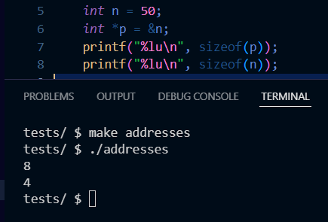
3. When we write char \*p, we are creating a variable p, that will store an address of a character/string type variable.
4. Similarly, when we type int \*p, we are creating a variable p, that will store the address of an int type variable.
5. When we declare a string s = "Hi!', and create a pointer char\* p to it, p actually stores the address of the first letter of the string s. So p stores the address of H.
6. When it comes to printing strings, printf just loops through the entire string character by character.
7. int main(void)
8. {
   1. string s = "HI!";
   2. printf("%p \n", s);
9. }
10. The program above will give you the memory address of "H".
11. We can also write, printf("%p \n", &s[0]);
12. The typedef keyword allows us to create our own data type.
13. typedef struct {int number; char\* name;} person;
14. The above line basically says, "Hey, give me a data type called person, which has a number option and a name option.
15. So in CS50, when we declare a variable with the data type "string", it's actually a typedef char\* string;

Strings:

1. In order to compare strings, we use strcmp.
2. The reason we cannot use the == sign is because we would only be comparing the addresses of the variables in which we stored our string.
3. Even if we used \*(variable name), we would only compare the first letter. (unless we did a loop but at that point, use strcmp)
4. Remember that a the variable that holds a string actually just holds its beginning character address.
5. The actual string is stored elsewhere.
6. When we use the double quotes, the \0 is automatically added to the end of your string, and the & operator is added to the beginning.
7. Single quotes (i.e just a character) do not have or need a \0.
8. 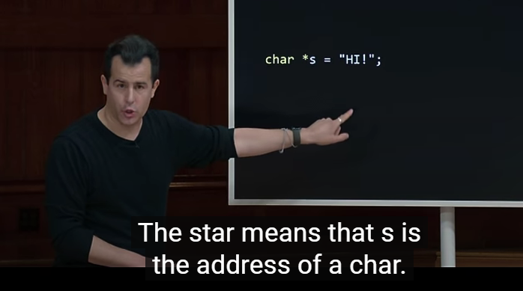
9. writing printf(“%c”, str[0]) is the same as writing printf(“%c”, \*str)
10. printf(“%c”, str[2]) == printf(“%c”, \*(str + 2))
11. 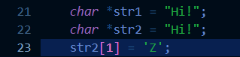
12. The above lines of code would cause a SEG FAULT. This is because when we use the char\* method to initialize a string, the string is stored in a Read-only section of the memory.
13. Also, in the above example, both the variables point to the same address in memory. So when we write str1 == str2, we actually get TRUE. However, if instead of directly hardcoding the initialization part, if we tried to accept user input for both as “Hi!”, then they would point to different sections in read only memory.
14. To be able to modify our string, we would have to write it as:
15. 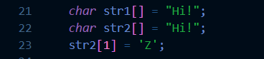
16. In the above case, the strings are stored in modifiable sections of memory.

Question: Why can't I store an integer address to a pointer of type char\* even though all pointers are meant to store addresses and all addresses take up 8 bytes of space to store in C?

Answer: The type of a pointer affects how the compiler interprets the data at the memory address it points to. For instance, dereferencing a char\* reads a single byte, while dereferencing an int\* reads multiple bytes (typically 4 or 8 bytes).

In summary, while all pointers store memory addresses and have the same size on a given architecture, the type of the pointer dictates how the compiler and runtime system interpret the data at the address.

malloc:

1. In order to copy one string onto another, we would have to use malloc.
2. malloc and free are two of the most important functions in C.
3. They are found in the stdlib header file.
4. When we type strlen(string name), we actually get the length of the string only, and it doesn't include the '\0'
5. the return type of the malloc function is an address (or NULL, depending on memory availability). So, we can only use it with pointers.
6. We should always error handle the malloc function, just in case it could not find enough memory.
7. Example: char\* p = malloc(sizeof(char) \* 8);
   1. if (p == NULL)
   2. {
   3. return 1;
   4. }

free:

1. free is the opposite of malloc. It frees up the memory that you used.
2. Syntax : char \*p;
   1. p = malloc(sizeof(char) \* 10);
   2. (perform operations);
   3. free(p);

NULL:

1. It just points to the address zero.
2. If you try to print the address of NULL, you get nil or NULL or 0.

valgrind:

1. Just a program to check your programs memory usage.
2. Syntax = valgrind ./outputfilename

- A memory leak is when you keep calling malloc without freeing any of the memory.

Garbage values:

1. Values of variables that you did not proactively set yourself, i.e, a remnant of a previous program.
2. When we pass a variable to a function, it creates a copy of that variable at a different memory address. This is called passing by value.
3. memory allocated using malloc comes from heap memory.
4. memory allocated to variables during program execution comes from the stack memory.
5. When we use too much heap memory, we could face heap overflow. The same situation happens for stack memory as well.
6. The above two are examples of buffer overflow.

String extras:

1. Suppose we declare a char\* of length 4 as follows:
2. char\* string[4];
3. This string has the ability to store three characters and a \0
4. However, if we were to use scanf to accept user input into this string, and the user were to enter a string bigger than size 4 like "Hello There", then the first four characters would be stored side by side (Since we told the computer hey I need a section of side by side memory that is of size 4) and the remaining would be stored in random locations of memory.

File I/O:

1. Some common functions when it comes to file handling include fopen(), fclose(), fprintf(), fscanf(), fread(), fwrite(), fseek()

2.